- How dose the web work?
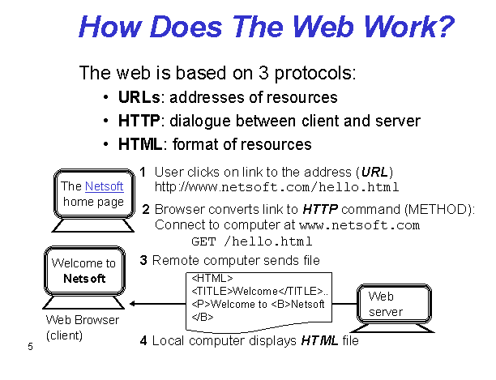
- How Do You Become a Web Developer?
To become a Web Developer, you should have an understanding of HTML, CSS, and JavaScript. It’s also recommended to learn about CSS and CSS frameworks. Developing these fundamental web development skills will give you the foundation and logic for communicating with programming languages.
How to become a Web Developer in five steps:
- Learn web development fundamentals
- Choose a development specialization
- Learn key programming languages for web development
- Work on projects to develop your Web Developer skills
- Build a web development portfolio
- what is the role of a web developer
Our web developers can be split into two different areas of roles and responsibilities - front-end and back-end.
- Front-End Developers
Front-end developers focus on programming languages, these include HTML, CSS and JavaScript. This particular coding helps create the interactive and visual parts of a website, which is everything you can see on a site.
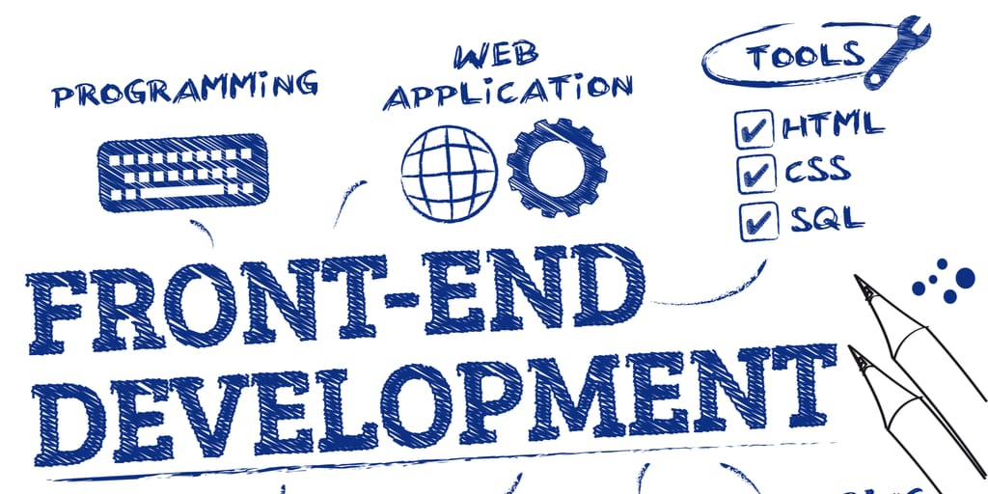
- Back-end Developers
Back-end development refers to the server-side of development, as opposed to the visuals and design side of the front end. The two work in tandem, without one, the other one wouldn’t be successful. The primary responsibility of back-end developer is to update and make changes, in addition to monitoring the functionality of the overall site.
